Laboratory work №7

Theoretical background
An optocoupler (or an optoelectronic coupler) is basically an interface between two circuits which operate at (usually) different voltage levels. The key advantage of an optocoupler is the electrical isolation between the input and output circuits. With an optocoupler, the only contact between the input and the output is a beam of light. Because of this it is possible to have an insulation resistance between the two circuits in the thousands of megohms. Isolation like this is useful in high voltage applications where the potentials of two circuits may differ by several thousand volts.
The most common industrial use of the optocouplers (or optically-coupled isolators) is as a signal converter between high-voltage pitot devices (limit switches etc.) and low voltage solid-state logic circuits. Optical isolators can be employed in any situation where a signal must be passed between two circuits which are isolated from each other. Complete electrical isolation between two circuits (i.e. the two circuits have no conductors in common) is often necessary to prevent noise generated in one circuit from being passed to the other circuit. This is especially necessary for the coupling between high-voltage information-gathering circuits and low-voltage digital logic circuits. The information circuits are almost badly exposed to noise sources and the logic circuits cannot tolerate noise signals.
In many applications SCR and triac power circuits are under the control of sensitive electronic systems. For example, it is not unusual to have a microprocessor system programmed to turn motors, lights, and heaters on and off. To reduce the possibility of power-line noise being induced into the control electronics, and to protect it in the event of an SCR or triac failure, it is highly desirable to provide isolation.
The ideal isolation scheme should only allow signal flow in one direction, should respond to dc levels, and should offer an extremely large resistance between the input and output circuits. These features are available in a class of optoelectronic devices called optocouplers or optoisolators.
The optical coupling method eliminates the need for a relay-controlled contact or an isolating transformer, which are traditional methods of providing electrical isolation between circuits. The optical coupling method is superior in many applications, because it gets rid of some of the less desirable features of relays and transformers.
The optocouplers works well on either ac or dc high-voltage signals. For this reason, signal converters employing optical coupling are sometimes referred to the universal signal converters.
The optocoupler is a device that contains an infra-red LED and a photodetector (such as a photodiode, phototransistor, Darlington pair, SCR or triac) combined in one package.
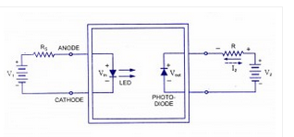
optocoupler

An autocoupler combining a LED and a photodiode in a single package is shown in figure. It has a LED on the input side and a photodiode on the output side. The left source voltage and the series resistor set up a current through the LED. Then the. light from the LED impinges on the photo-diode, and this sets up a reverse current in the output circuit. This reverse current develops a voltage across the output resistor R. The output voltage then equals the output supply voltage V₂ minus the voltage drop across the load resistor R. When the input voltage is varied, the amount of light fluctuates.
Types of Optocouplers:
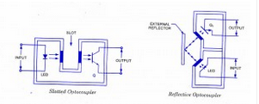
reflective-slotted-optocoupler

1. Slotted Optocoupler – A slotted optocoupler has a slot moulded into the package between the LED light source and the phototransistor light sensor; the slot houses transparent windows, so that the LED light can normally freely reach the face of transistor , but can be interrupted or blocked via opaque object placed within the slot. The slotted optocoupler can thus be employed in a variety of presence detecting applications, including end-of-tape detection, limit switching, and liquid level detection.
2. Reflective Optocoupler – Here the LED and phototransistor are optically screened from each other within the package, and both face outwards (in same direction) from the package. The construction is such that an optocoupled link can be set up by a reflective object (such as metallic paint or tape, or even smoke particles) placed a short distance outside the package, in line with both the LED . The reflective coupler can thus be employed in applications such as tape-position detection, engine-shaft revolution counting or speed measurement, or smoke or fog detection etc.
Characteristics of an Optocoupler:
Current Transfer Ratio (CTR). One of the most important parameters of an optocoupler device is its optocoupling efficiency. This parameter is maximized by closely matching spectrally the LED and the phototransistor (which usually operate in the infra-red range). The optocoupling efficiency of an optocoupler may be conveniently specified by the output-to-input current transfer ratio (CTR) i.e., the ratio of the output current I_{c} (measured at the collector terminal of the phototransistor), to the input current I_{F} flowing into the LED.
Input-to-Output Isolation Voltage (V_{iso}). This is the maximum potential difference (dc) that can be allowed to exist between the input and output terminals. Typical values range from 500 V to 4 kV.
Maximum Collector-Emitter Voltage, V_{CE} _{(max)}. This is the maximum allowable dc voltage that can be applied across the output transistor. Typical values may vary from 20 to 80 volts.
Bandwidth. This is the typical maximum signal frequency (in kHz) that can be usefully passed through the optocoupler when the device is operated in its normal mode. Typical values vary from 20 to 500 kHz, depending on the type of device construction.
Response Time. Divided into rise time t_{r} and fall time t*. For a phototransistor output stages, t_{r} and tr are usually around 2 to 5 us.
A simple isolating optocoupler uses a single phototransistor output stage and is usually housed in a six-pin package, with the base terminal of the phototransistor externally available. In normal use the base is left open circuit, and under such a condition the optocoupler has a minimum CTR value of 20 % and a useful bandwidth of 300 kHz.

Working process
- Assemble the circuit below
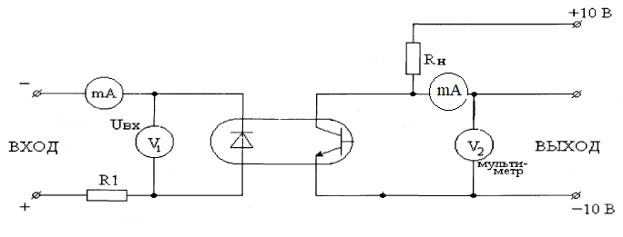
- Obtain measurements of voltage and current using output voltage and current changing voltage of power source;
- Construct I-V curve;
- Obtain CTR (current transfer ration) measuring input and output current
$$CTR=\frac{I_{out}}{I_{in}}$$
- Construct the dependence of the CTR on output voltage.

